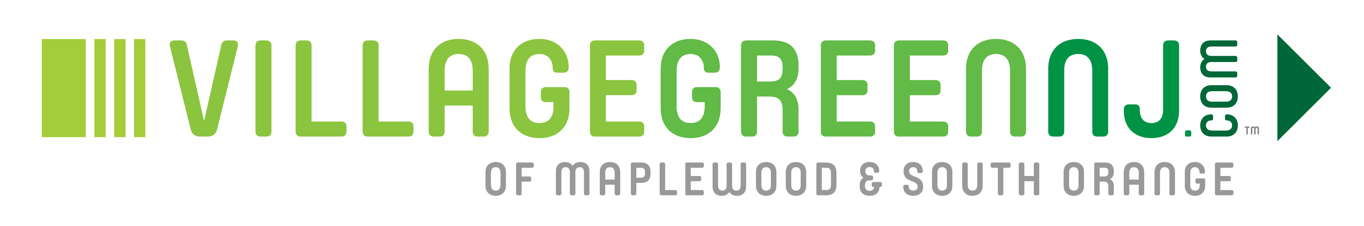

SPONSORED POST INFORMATION

SPONSORED POSTS:
- If you are looking to submit blog-type posts that provide valuable information to our readers while promoting your business, Sponsored Posts are the way to go.
- The article would be displayed with a “Sponsored Post” heading and would appear on the Home Page. The article would also be posted on the preferred sub-page where it would stay in perpetuity.
- The Sponsored Post would also be included as an item in our daily e-newsletter and posted on Facebook and Twitter.
- Note that content would need to be vetted and approved by VillageGreenNJ.com publishers.
- Cost $200

REQUIREMENTS:

- Estimated 300-500 word blog
- Preferred headline
- Photo to be posted along with the blog
- Date, time, registration link, phone number, contact information (the who, what, when, why and how of the event or business described in the blog)
- Send your Sponsored Post to Publishers Mary Mann and Carolyn Maynard-Parisi at Mary@villagegreennj.com and Carolyn@villagegreennj.com. They will review the post and get back to you with any changes.

PLEASE NOTE: Sponsored Posts should be something of editorial value for the reader, not just promotion of a service or product (that's what ads are for!). The content should be presented in a way that addresses a need for the reader/community or identifies a trend or that has a news interest. Examples include featured open houses, real estate trend/market reports, educational opportunities/aids, or a unique and new shopping experience or service. If you are uncertain about your sponsored content topic, your ad sales rep will consult with the editors.

QUESTIONS: Please contact Shana Teitelbaum at shana@villagegreennj.com or 917-414-9720.

