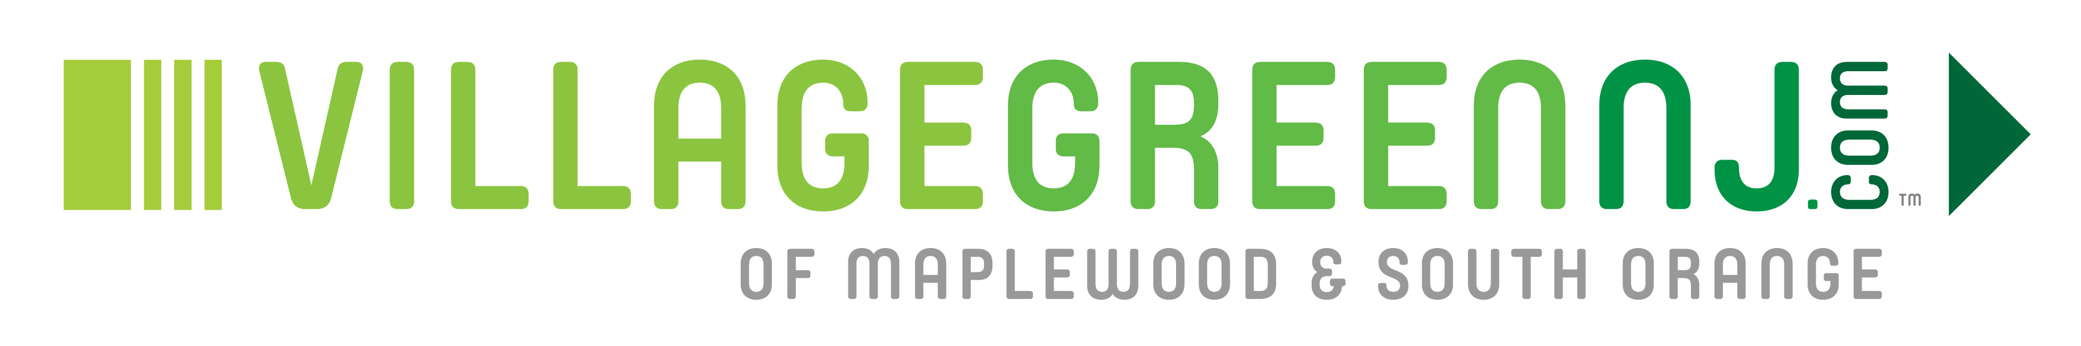
AD RATE SHEET
EFFECTIVE 12/01/2016

HEADER ADS:
- Our most prominent ad spot, the Header Ad is seen at the top of each page whether viewing on a computer or a smartphone.
- May rotate with up to 10 other advertisers.
- Size 800x100 in jpeg format.
- $450 per month

SUB-HEADER ADS:
- The Sub-Header is a great ad spot because it is also at the top of each page, slightly below the Header. It is seen at the top of the page whether viewing on a computer or a smartphone.
- Does NOT rotate with other advertisers.
- Size 936x180 in either jpeg or rotating gif format.
- $350 per month

BOX ADS:
- Box ads are a great option as they receive a high number of views at a lower price point. These ads are seen on the right side of each page when viewing on a computer and below the articles when viewing on a smartphone.
- Does not rotate with other advertisers.
- Size 300x250 in jpeg or gif format.
- $250 per month

IN-STORY ADS:
- INSIDE AD: The first "In-Story Ad" is called the "Inside Ad" and appears in a story after the fourth paragraph. $250 per month

- BELOW CONTENT AD: The second "In-Story Ad" is called the "Below Content" Ad and appears at the end of the story. $200 per month

- BEFORE COMMENTS AD: The third "In-Story Ad" is called the "Before Comments Ad and appears before the comment section on each story. $150 per month

NEWSLETTER ADS:
- The e-newsletter is free to all who register and is distributed daily. The number of free subscribers continues to grow but as of April 2017 is roughly 950.
- There are two ad spots at the top of the e-newsletter.
- $250 per month

SPONSORED POSTS:
- If you are looking to submit blog-type information that provides valuable information to our readers while promoting your business, Sponsored Posts are the way to go.
- The article would be displayed with a “Sponsored Post” heading and would appear on the Home Page. The article would also be posted on the preferred sub-page where it would stay in perpetuity.
- The Sponsored Post would also be included as an item in our daily e-newsletter and posted on Facebook and Twitter.
- Note that content would need to be vetted and approved by VillageGreenNJ.com publishers.
- Cost $200

BONUS:
We offer our paying advertisers the opportunity to publish blog-type content on The Village Green for no extra charge. This allows us to further inform our readers with information they would like to see while granting advertisers additional exposure.

NOTE THE FOLLOWING:
- We only require a 3 month minimum.
- You may change your ad as often as you’d like – for no extra charge.
- Your ad will be linked to the URL of your choosing.
- We can provide metrics regarding views, hovers, click-throughs, basic demographics, upon request.
- We are happy to offer a 5% discount for 6 months paid upfront and a 10% discount for 12 months paid upfront.
- We prefer payment by check but will accept a credit card for an additional 3% fee to cover the cost of processing.

