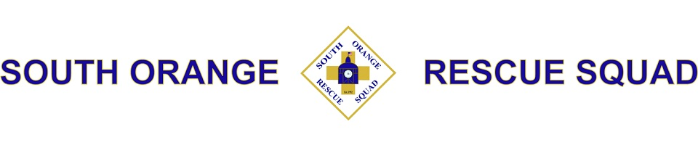
The South Orange Rescue Squad is an all-volunteer team that provides free emergency medical services to South Orange, Maplewood and the surrounding communities. Our operating budget comes from donations from the community and NOT from taxpayer dollars.

WE NOW NEED YOUR HELP. Our headquarters on Third Street was recently torn down to make room for a real estate development. The developer made a financial contribution as payment for our old building, but it is not enough to build the new one. It is estimated that we need to raise at least another $100,000 to complete the project.  You can sponsor engraved bricks that will become a permanent part of two paths leading to our new building, and engraved tiles which will line the walls inside the front entrance.  These personalized bricks and tiles will be laser engraved with the inscription and logo of your choice and are perfect for honoring your family name, celebrating a precious memory, memorializing a loved one or just showing your business or family's support for the SORS.  Your personalized text and image will be a part of our building forever and will stand as a permanent legacy.  You can upload your own logo / clip art to be used--email sorescue@verizon.net for more info.  For $25, a 4” by 4” Replica Tile with the same inscription will be mailed to you |  | 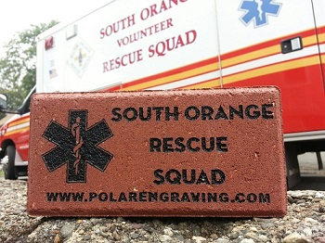  Donor Information  Name: _____________________________________  Address:____________________________________  City, State: _________________ Zip code: __________  Email Address: _______________________________  Phone Number:(___)___________________________  Clip Art #: __________________________________  Donation Amount: _____________________________  Please Make Checks Payable To:  South Orange Rescue Squad  Mail To:  13 Fourth Street  South Orange, NJ 07079
ANY BUSINESS OR INDIVIDUAL INTERESTED IN CONTRIBUTING $2,500 OR MORE
PLEASE EMAIL SORESCUE@VERIZON.NET FOR INFO ON OUR SPONSORSHIP OPPORTUNITIES
Brick Information  4” x 8” engraved brick $150 with Clip Art or Logo $160  Clip Art ID: _________Replica Tile $25: (Yes/No) _________  8” x 8” engraved brick $250.00 with Clip Art or Logo $260.00  Clip Art ID: _________Replica Tile $25: (Yes/No) _________  12” x 12” engraved brick $500.00 with Clip Art or Logo $510.00  Clip Art ID: _________Replica Tile $25: (Yes/No) _________ | Tile Information  6” x 6” engraved tile $125.00 with Clip Art or Logo $135.00  Clip Art ID: _________Replica Tile $25: (Yes/No) _________  12” x 12” engraved tile $225.00 with Clip Art or Logo $235.00  Clip Art ID: _________Replica Tile $25: (Yes/No) _________  If selecting clip art or a logo please do not write in shaded areas.  SO01 A01 K01  K05 K39 K42
For additional Clip Art or to order online please visit: www.polarengraving.com/SORescueSquad

