***Items Needed For South Orange & Maplewood***

***School District Parenting Center***

***2014 Holiday Toy Drive***

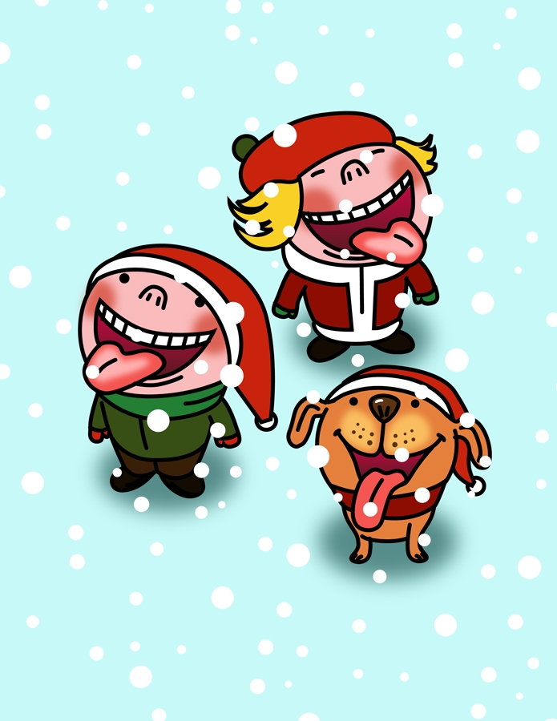

***C:\Users\lorrainecaputo\AppData\Local\Microsoft\Windows\Temporary Internet Files\Content.IE5\58Z6NCFJ\MC900326378[1].wmf C:\Users\lorrainecaputo\AppData\Local\Microsoft\Windows\Temporary Internet Files\Content.IE5\SIRWYTNC\MC900355663[1].wmf 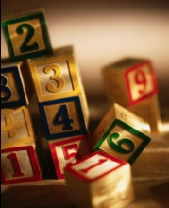C:\Users\lorrainecaputo\AppData\Local\Microsoft\Windows\Temporary Internet Files\Content.IE5\4JCM2NST\MC900355711[1].wmfC:\Program Files (x86)\Microsoft Office\MEDIA\CAGCAT10\j0299763.wmf***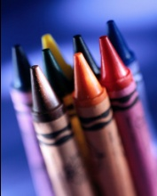

**All**

New Books

Crafts/Art Supplies

Footballs

Basketballs

Games

Watches (No more than $10-$15)

Hats, Scarves and Gloves

Wrapping Paper: For the Parents of the Children

Batteries

Gift Certificates

**Young Children**Toddler Toys

Stuffed Toys  
Dolls - Barbie and Baby Dolls Of All Ethnicities

Trucks, Cars, Matchbox Cars, Airplanes

Building Toys, Blocks and Legos

Dress Up Outfits

**Teens (General)**

MP3 Players

DVD Player

Gift Cards to local pizzerias, coffee shops, etc.

**Teen Girls**

Purses

Jewelry

Perfume, Body Lotion and Nail Polish

Hair Products and Personal Toiletries

**Books**

**Teen Boys**

Personal Toiletries

Basketballs

Footballs

Soccer Balls

Books

**Please Note:** In the past, the Parenting Center has received far more gifts for younger children, so particular assistance is needed in the teen category.

Toys may be delivered to collection boxes at your child’s school. The High School will have two collection boxes near the security desk. There will be boxes at Scriveners in Maplewood & Spark House Kids in South Orange and other locations TBA.

☺ Thank you for your generous support! ☺