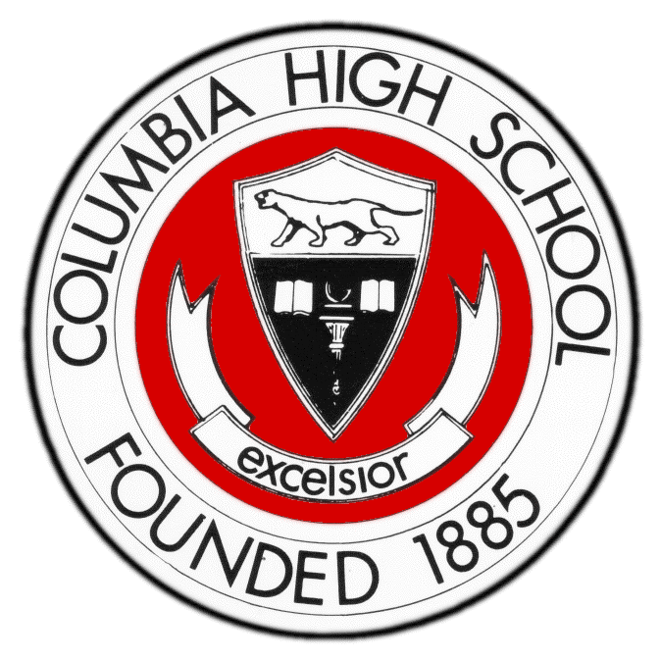

School District of South Orange and Maplewood

COLUMBIA HIGH SCHOOL

17 Parker Avenue • Maplewood, New Jersey 07040
973-762-5600 x1012 FAX 973-378-5234

December 7, 2015

Dear Parents, Guardians, and CHS Cougars,

We are pleased to announce that we will be hosting our annual Advanced Placement (AP) Forum on Wednesday, January 6 at 7:00 pm at CHS. AP courses are rigorous, college-level classes offered at the high school level. They are strong predictors for success at the college level, and we encourage students to seek these learning opportunities. Please visit and bookmark www.apcentral.collegeboard.com. Spending some time on that site before you attend our AP Forum will help answer many questions you may have about the College Board Advanced Placement program. The information there will also help you have conversations about where your student(s) are on the readiness road to AP courses, and help you plan out an academic trajectory at CHS.

The purpose of the forum is to introduce our AP course offerings to all prospective students and their parents/guardians. The chart below identifies each of the courses and our corresponding grade recommendations. This evening is designed to provide you and your student the opportunity to learn more about the content, work, and expectations of the College Board and CHS with regard to enrollment in Advanced Placement classes.

The SOMSD’s Board of Education recently adopted an Access and Equity policy to assure all students the opportunity to enroll in courses at academic levels for which they are ready. Learning more about the trajectory toward AP classes at CHS through our school’s course catalog (http://www.somsd.k12.nj.us/Page/3654)
and conversations with your students, their teachers, school counselors, and content area supervisors are key components of our work together as partners in your child’s education and future.

Scheduling decisions will be upon us early in the new year, and we know that this night will add to on-going, important conversations between you, your children, their counselors, and teachers. Deciding to take college-level courses in high school is an opportunity we believe all students should have, and we are here to support you in making the decisions that are best for your student.

We look forward to seeing you on January 6 at 7 pm.

Best regards,

Elizabeth M. Aaron, MAT, M.Ed.
Principal
eaaron@somsd.k12.nj.us
972-762-5600 ext. 1012

EMA/jm

ART (Mara Rubin, mrubin@somsd.k12.nj.us)
AP Studio Art | 12th grade
AP Art History | 10th, 11th and 12th grades
ENGLISH/LANGUAGE ARTS (Janine T. Gregory, jtgregor@somsd.k12.nj.us)
AP Language and Composition | 11th grade
AP Literature and Composition | 12th grade
MATHEMATICS (C.Beattys, cbeattys@somsd.k12.nj.us)
AP Statistics | 10th, 11th and 12th grades
AP Calculus (AB) | 11th and 12th grades
AP Calculus (BC) | 11th and 12th grades
MUSIC (Mara Rubin, mrubin@somsd.k12.nj.us)
AP Music Theory | 11th and 12th grades
SCIENCE (Alan Levin, alevin@somsd.k12.nj.us)
AP Biology | 12th grade
AP Chemistry | 11th grade
AP Environmental Science | 12th grade
AP Physics | 12th grade
SOCIAL STUDIES (Chris Preston, cpreston@somsd.k12.nj.us)
AP US History I (year 1 of 2) | 10th grade
AP US History II (year 2 of 2) | 11th grade
AP European History | 11th and 12th grades
AP Government & Politics | 11th and 12th grades
AP Psychology | 11th and 12th grades
WORLD LANGUAGES (Ramon Robles, rrobles@somsd.k12.nj.us)
AP French Language | 11th and 12th grades
AP Spanish Language and Culture | 11th and 12th grades
AP Spanish Literature | 11th and 12th grades
AP Italian Language | 11th and 12th grades

Below please find the AP academic content areas and locations for the sessions. The first session will begin promptly at 7 pm. Please report directly to these locations, where our content area supervisors will host the sessions. Each session will last for approximately 25 minutes to allow you time to move to another. Each session will run 4 times to allow you to attend sessions in multiple subject areas.

Content Areas | Room #
Mathematics | Cafeteria (near food service area)
Fine & Performing Arts | D101
Language Arts | A205 & A207
Social Studies | Black Box Theater
Science | Cafeteria (near Parker Avenue)
World Languages | D100

INFORMATIONAL SESSIONS
Session #1 | 7:00-7:25
Session #2 | 7:30-7:55
Session #3 | 8:00-8:25
Session #4 | 8:30-9:00

