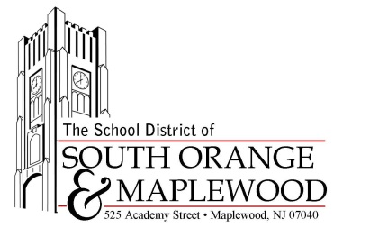

Paul Roth
Chief Information Officer/Director of Assessment
Tel. (973) 762-5600 x1835/Fax (973) 378-9464
proth@somsd.k12.nj.us

December 2015

Dear Parent/Guardian,

Attached are your child’s results from a new state test in English language arts/literacy (ELA) and/or mathematics known as the Partnership for Assessment of Readiness for College and Careers (PARCC) that your child participated in last spring. These tests were designed to replace the New Jersey Assessment of Skills and Knowledge (NJ ASK) and the High School Proficiency Assessment (HSPA) and match the content and skills outlined in the new standards that are guiding instruction. These new tests moved away from typical multiple choice exams and asked questions that require students to explain their answers.

Your child’s performance level, as well as the school and district’s performance levels, may appear lower this year as compared to prior years. These new tests measure more complex, real-world skills such as critical-thinking, writing, and problem solving. Additionally, this first year of testing is a transition year. For these reasons, these scores cannot be compared to previous test scores. Instead, they are setting a new baseline from which progress can be measured moving forward.

Please note that the state calculated the school results based upon the students zoned for the school and not based upon the students attending the school; therefore, the school scores do not represent the overall performance of the students attending the school.

I hope you will find that the attached report provides you with more detailed information about your child’s learning. Each subject is broken down into categories of skills and content to identify where a student is doing well and where he or she needs some additional help. You can find additional resources at the following websites:

- Video explaining the score reports: http://www.understandthescore.org/
- Additional resources for parents: http://www.bealearninghero.org/
- Information about the PARCC assessment: http://www.parcconline.org/resources/parent-resources
- New Jersey specific information: http://www.state.nj.us/education/assessment/
Sincerely,

Paul Roth

