South Orange-Maplewood School District March 18, 2016
525 Academy St.
Maplewood, NJ 07040

Dear President Baker and Board of Education Members:

On behalf of the membership of the New Jersey Library Association we are urging the South Orange-Maplewood School District to reconsider its proposal to eliminate school library media specialists in its proposed budget for the upcoming school year.
Through their educational training, school library media specialists in New Jersey are not only certified as classroom teachers but receive graduate level training in literature, research and technology skills essential in a twenty-first century learning environment. No other faculty member is uniquely qualified to ensure that a student has the literacy background and research skills to succeed in the increasingly competitive global educational environment which all students must face.
In New Jersey, all libraries (school, public, academic and special) are joined together through the New Jersey Library Network, a state funded program which provides many services including the purchase of electronic research materials appropriate for students of all ages. A skilled media specialist is the most important teacher to guide students on the effective use of these resources.
The membership is comprised primarily of public and academic librarians. We understand the critical role that a school library media specialist plays in the educational development of a student. We see the results every day. Students who come into our libraries fully prepared to use our resources are those who have a strong foundation in their local school. We have seen how the elimination of school media positions leaves students unable to handle complex research assignments. Students without these skills struggle. The elimination of a school media specialist has a significant impact on a student’s future academic career.
Our Association has partnered with the NJ School Librarian Association on a statewide survey of school media specialists. We have heard in their own words how difficult it would be on both students and staff if their positions were eliminated.
The education community recently celebrated the passage of The Every Student Success Act which includes provisions which specifically recognizes the role of school media specialists and school library programs in the educational development of each student. We strongly believe that the inclusion of school media programs in this new legislation is a direct result of the evaluation of numerous studies which have definitely concluded that school media programs are fundamental to student achievement. It seems extremely shortsighted to remove school library media positions now as this new legislation is being implemented. It is clear to us that school library media specialist are posed to play an even more significant role in the educational program of a school district than ever before when this new legislation is fully adopted.
These are difficult economic times for all public services. We strongly urge you to continue to fund these school library media positions. We believe you will never regret this decision. The result will be students who are skilled in using information to meet the challenging demands of the future.
Sincerely,
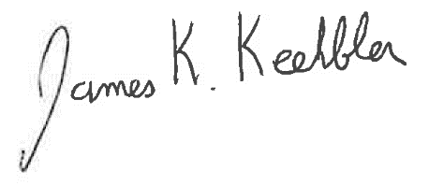
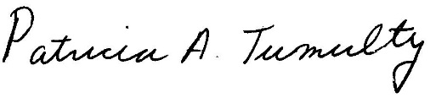

James Keehbler, President Patricia Tumulty, Executive Director

