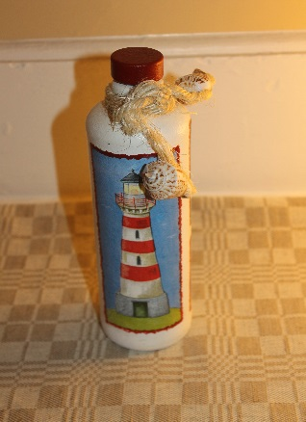
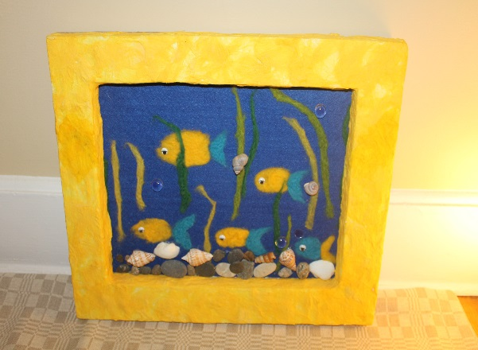

Please join us at our 2017 Fundraising Event of The Art of Giving Project
Your help will show these children that their lives matter
&
help them live healthy and happy lives

10 June 2017
5:30 pm
Wellness Lounge
14 S Orange Ave, South Orange

Please RSVP by June 1st to annalitvak@outlook.com

The Art of Giving Project is a project designed to organize events where arts and crafts made by Latvian orphans and disabled children are sold and the money collected is used to provide aid such as medicine, shoes, school supplies, beds, clothes, as well as orphanage repairs and renovations on an ongoing basis
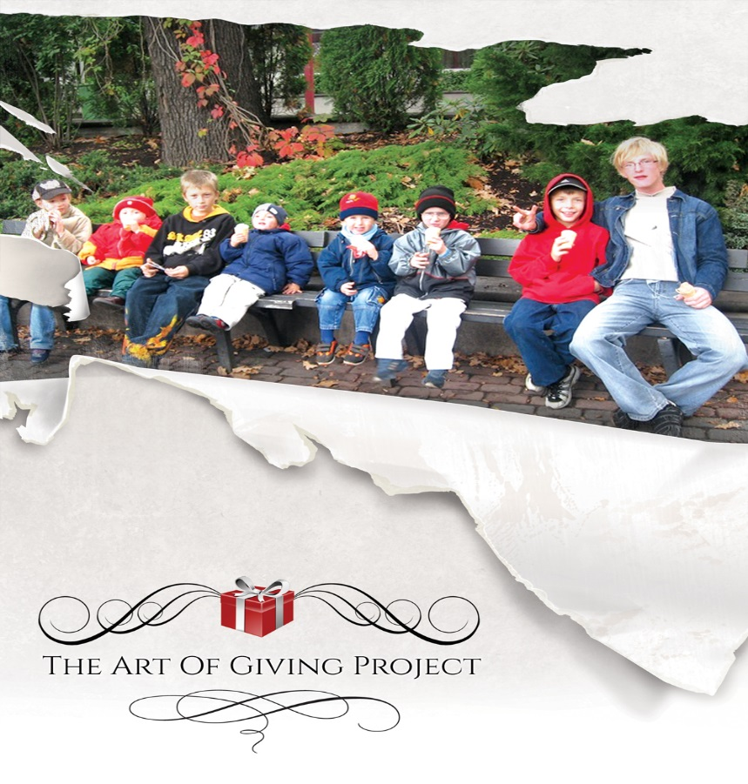
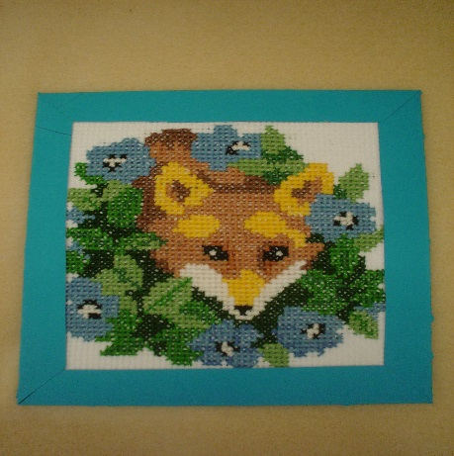
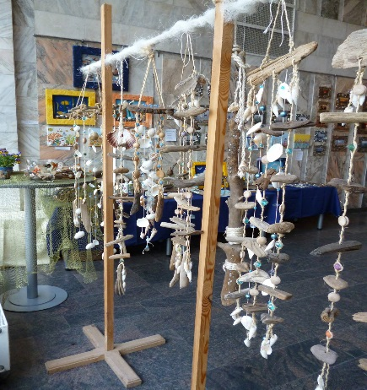
For more information, please go to our website: www.theartofgivingproject.com

