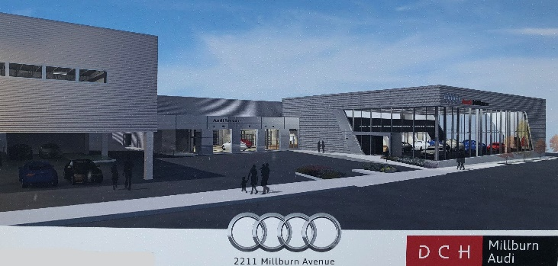
DCH Millburn Audi
“Automotive News Best Dealership to Work For,”
is building a brand new, state-of-art facility and hiring immediately to build our team for future growth! If you are interested in an opportunity to grow your career with a Fortune 300 Company,
Join us for a Career Information Session
ALL LEVELS OF EXPERIENCE WELCOME!
Automotive Sales Representatives
Call Center representatives
Automotive technicians
Cashiers
Receptionists- full and part time

WHEN: Wednesday, MARCH 20th 11am-2pm
WHERE: DCH Millburn Audi
2211 Millburn Ave, Maplewood NJ

