Essex County Coronavirus Cases
Updated: Tuesday, May 5, 2020
Cumulative Confirmed COVID-19 Cases and Deaths Essex County, NJ
Municipality | 5/4/20 pm | 5/5/2020 9am | Deaths 5/5/20 am
Belleville | 846 | 848 | 50
Bloomfield | 899 | 910 | 49
Caldwell | 99 | 100 | 6
Cedar Grove | 347 | 349 | 80
East Orange | 1565 | 1572 | 141
Essex Fells | 19 | 18 | 2
Fairfield | 117 | 117 | 14
Glen Ridge | 33 | 32 | 7
Irvington | 1170 | 1177 | 120
Livingston | 409 | 409 | 58
Maplewood | 259 | 259 | 20
Millburn | 124 | 124 | 5
Montclair | 369 | 368 | 38
Newark | 5902 | 5965 | 453
North Caldwell | 38 | 38 | 4
Nutley | 439 | 438 | 30
Orange | 726 | 734 | 52
Roseland | 73 | 73 | 12
South Orange | 83 | 84 | 3
Verona | 108 | 108 | 11
West Caldwell | 190 | 190 | 35
West Orange | 979 | 978 | 134
Total | 14794 | 14891 | 1324
Negative tests (County) | 15567 | 15675
Statewide positive |  | 128269
Statewide deaths |  | 7910
- Social distancing, hand hygiene, and other steps to prevent infection must be followed at all times in all municipalities regardless of the number of cases.
- The number of infected individuals in any municipality is likely to be much greater than indicated as this data ONLY includes persons who have been tested and whose lab results have been reported in the State’s data system.
- This data will not match any other report since cases are continually entering the system and local health departments may reassign place of residence as appropriate during their investigations.

Essex County: Demographics of Individuals with Confirmed COVID-19
Updated 5/1/20

Age Group

 |  | Frequency | Percent
Valid | 0 to 4 | 48 | .3
 | 5 to 17 | 164 | 1.1
 | 18 to 29 | 1477 | 10.3
 | 30 to 49 | 4826 | 33.8
 | 50 to 64 | 4336 | 30.3
 | 65 to 79 | 2242 | 15.7
 | 80+ | 1174 | 8.2
 | Total | 14267 | 99.8
Missing | System | 30 | .2
Total |  | 14297 | 100.0
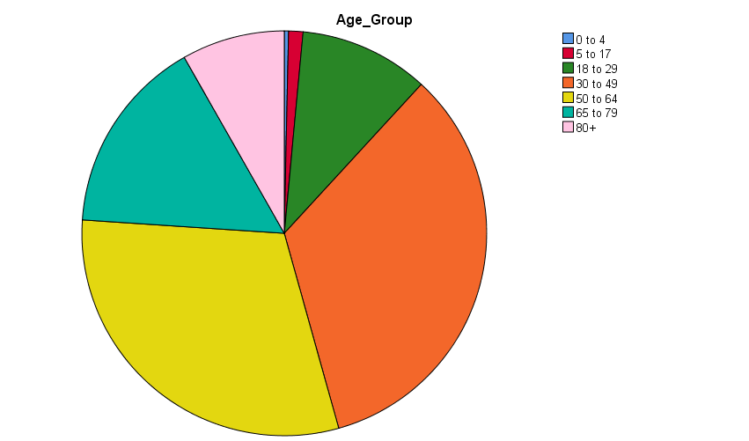

Gender

 |  | Frequency | Percent
Valid | FEMALE | 7319 | 51.2
 | MALE | 6942 | 48.6
 | UNKNOWN | 36 | .3
 | Total | 14297 | 100.0

Essex County: Demographics of Deceased Individuals with Confirmed COVID19
Updated 5/1/20

Age Group of Deceased
 |  | Frequency | Percent
Valid | 5 to 17 | 1 | .1
 | 18 to 29 | 9 | .7
 | 30 to 49 | 69 | 5.5
 | 50 to 64 | 276 | 22.0
 | 65 to 79 | 458 | 36.5
 | 80+ | 440 | 35.1
 | Total | 1253 | 99.8
Missing | System | 2 | .2
Total |  | 1255 | 100.0

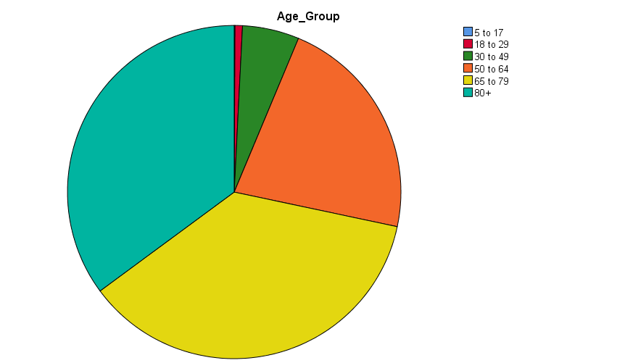

Gender of Deceased

 |  | Frequency | Percent
Valid | FEMALE | 553 | 44.1
 | MALE | 702 | 55.9
 | Total | 1255 | 100.0

