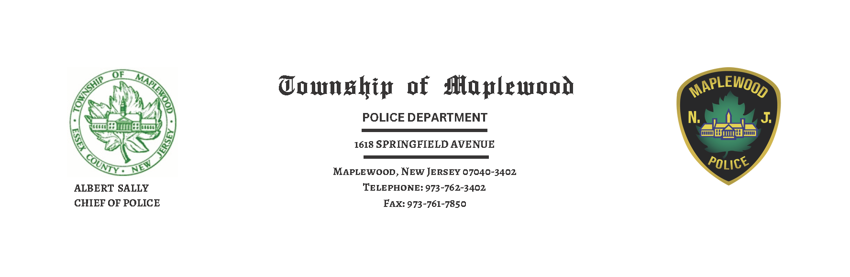

Press Release

On Wednesday September 3, 2025 at approximately 3:49 PM, Maplewood Police Officers responded to the intersection of Boyden Avenue and Tuscan Road on a report of pedestrians struck by a motor vehicle.
Officers arrived on scene along with South Essex Fire Department/ EMS and rendered aid to the adult mother and her 5-year-old son. Both declined medical transport and elected to have a family member transport them to an area hospital. Both were later released with minor injuries.
After an on-scene investigation, it was determined that the driver of a 2014 Honda Pilot, 60-year-old Tycina Washington of Little Falls, NJ, was traveling north on Boyden Avenue. She came to the intersection of Boyden Avenue and Tuscan Road when she made a left turn onto Tuscan Road. Washington reported that she did not see the pedestrians in the crosswalk and did not stop in time. Summonses were issued to Washington for Failure to Stop for Pedestrian in a Crosswalk, Careless Driving, and Failure to Exhibit Documents.
In August the Maplewood Police Department kicked off their Pedestrian Safety Campaign by conducting multi-officer traffic details throughout the township. Residents can expect the campaign to continue into the school year.

